**MongoDBCase Study-1**

**By Afreen Sultana A**

db.products.insertMany([{"id": "1","product_name": "Intelligent Fresh Chips","product_price": 655.00,"product_material": "Concrete","product_color": "mint green"},

{"id": "2","product_name": "Practical Fresh Sausages","product_price": 911.0,"product_material": "Cotton","product_color": "indigo"},

{"id": "3", "product_name": "Refined Steel Car","product_price": 690.00,"product_material": "Rubber","product_color": "gold"},

{"id": "4","product_name": "Gorgeous Plastic Pants","product_price": 492.00,"product_material": "Soft","product_color": "plum"},

{"id": "5","product_name": "Sleek Cotton Chair", "product_price": 33.00,"product_material": "Fresh","product_color": "black"},

{"id": "6","product_name": "Awesome Wooden Towels","product_price": 474.00, "product_material": "Plastic","product_color": "orange"},

{"id": "7","product_name": "Practical Soft Shoes","product_price": 500.00,"product_material": "Rubber","product_color": "pink"},

{"id": "8","product_name": "Incredible Steel Hat","product_price": 78.00, "product_material": "Rubber","product_color": "violet"},

{"id": "9","product_name": "Awesome Wooden Ball","product_price": 28.00,"product_material": "Soft","product_color": "azure"},

{"id": "10","product_name": "Generic Wooden Pizza","product_price": 84.00,"product_material": "Frozen","product_color": "indigo"}])

1. **Find all information about the Products**

db.products.find()

|  |  |
| --- | --- |
|  |  |

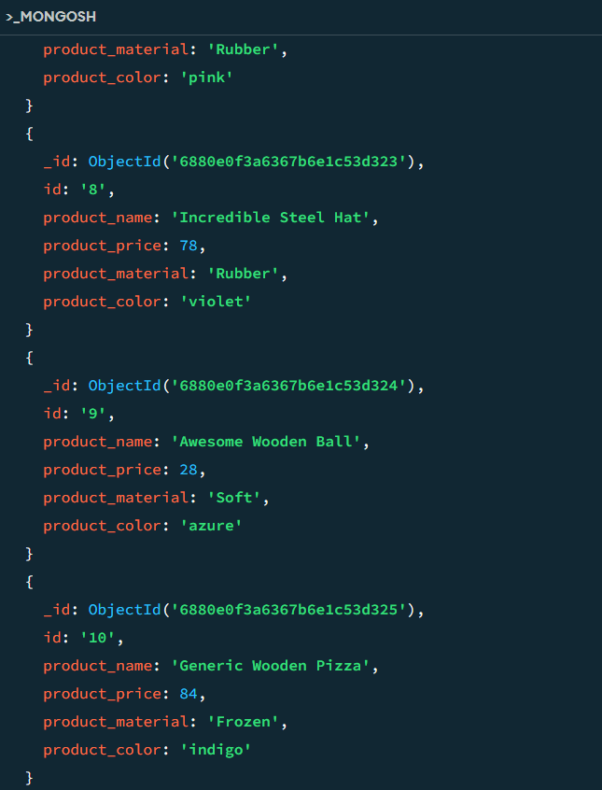

1. **Find the product price which are between 400 to 800**

db.products.find({product_price:{$gte:400,$lte:800}})

|  |  |
| --- | --- |
|  |  |

1. **Find the product price which are not between 400 to 600**

db.products.find({product_price:{$not:{$gte:400,$lte:600}}})

|  |  |
| --- | --- |
|  |  |

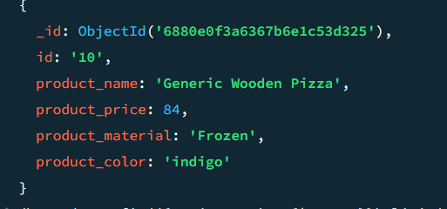

1. **List the four product which are grater than 500 in price**

db.products.find({product_price:{$gt:500}}).limit(4)

(Its shows only 3 products because there only 3 products which is greater than 500)

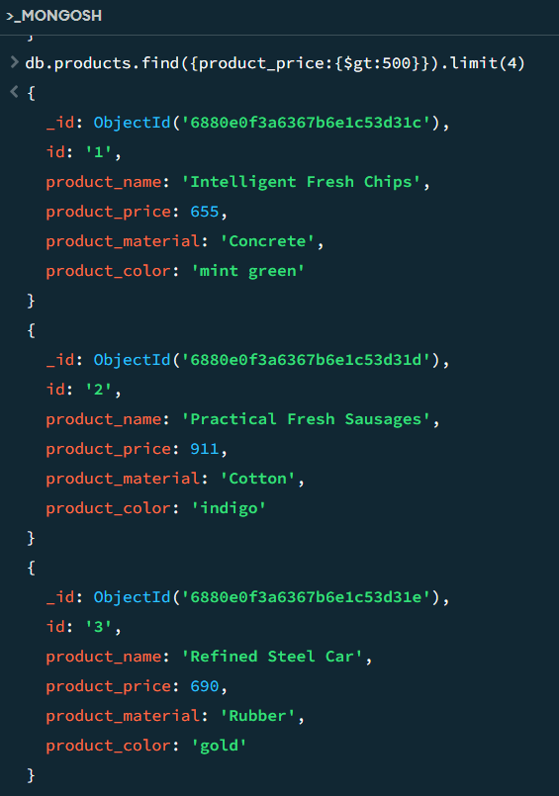

1. **Find the product with a row id of 10**

db.products.find({id:'10'})

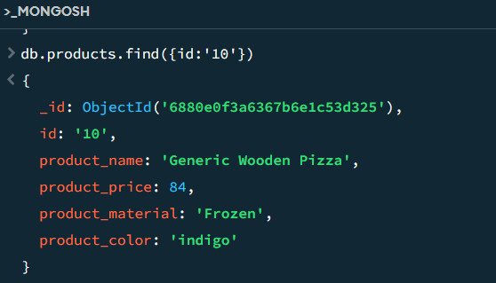

1. **Find all products which contain the value of soft in product material**

db.products.find({product_material:{$regex:/soft/i}})

